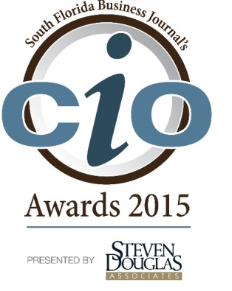
Official Application
The 2015 SFBJ CIO Awards presented by Steven Douglas Associates honors chief information officers who lead their organizations in delivering business value and innovative use of IT. Corporate Sponsors: Comcast Business. Associate Sponsor: i-Coast CIO Council of South Florida.

The awards will recognize South Florida-based CIOs who have demonstrated these key characteristics:
- Ability to work productively with business partners
- Alignment of technology direction with the company's strategy
- Innovation either internally or in the form of new products or services
- Growth in their information technology team
- Demonstration of strong leadership
- Involvement in their community
Directions:
- Fill out this application in its entirety. Please be sure that your responses are detailed and that all parts of the question are answered. Feel free to attach supportive documentation in PDF format. We ask that you do not include web-links and other outside resources as references as the advisory selection panel will review the application only.
- Save this application as a Word document clearly titled with the applicant’s name and company. For example: JohnDoe – ABC Co.doc.

- Submit completed applications to: sfbjevents@bizjournals.com no later than Friday, August 28, 2015. Finalists will be announced on Thursday, September 10, 2015. EXTENSIONS WILL NOT BE PERMITTED!
Questions? Contact Maureen D’Silva at mdsilva@bizjournals.com or call 954-949-7522.

Required Information
Eligibility requirements: All candidates should perform the top technology executive role at their company, regardless of their title (ie: CIO, CTO, VP of Information Technology, etc.) The company must have a minimum of 10 employees and be in business for a minimum of two full years.
Applicant Information:
Nominee Name:
Nominee Title:
Nominee’s Company:
Nominee’s Company Address:
Nominee’s E-mail Address:
Nominee’s Phone Number:
How long has applicant been with current company?
How long has applicant been in the IT industry?
Nominator Contact Information: (Only complete this if you are the nominator)
Contact’s Name:
Contact’s Company:
Contact’s Address:
Contact’s E-mail Address:
Contact’s Phone Number:

Which award are you applying for?
o Private Company CIO
o Public Company CIO
o CIO Lifetime Achievement Award (This award honors a technology veteran with more than 10 years in the industry, at least five of those in South Florida. The honoree will have a unique vision and accomplishments that have propelled his/her company to lead the way in technology — or the use of technology in his/her industry. The honoree must hold an executive position, and at one time held the chief information/chief technology officer position when the technology advancements that he/she championed at their company were made. In addition to technology guru, the candidate must have a proven leadership with his/her staff, improved the company’s top and bottom lines and is active in the community.

1. First, tell us about your COMPANY. Please describe your company, IT organization and reporting relationship. Be sure to include what your company does and the role of the IT department. You must include all information requested. Please limit company description to 750 words.

1a. Number of full time employees:
2013:
2014:
2015:

1b. Annual Revenue: This information is required so that we can understand the size and scope of the company. We do not publish this information. It is used for advisory panel review purposes only. Approximate figures are acceptable.
2013:
2014:
2015:

2. NOW, tell us about YOU, the CIO: Describe your professional accomplishments in the past two years relating to your role as CIO. In other words, tell us about your leadership. There is no limit on how much information you provide.

3. What is the role of IT leaders on the senior executive team of your company? As a CIO, are you involved in day to day decision making? How about strategic planning? What have you done in this role to drive transformative value in your company? Remember, when answering, details are important. Please be sure to detail your CIO role and rather than the overall company itself.

4. Please describe how you have fostered a culture that consistently generates new value from IT. Ideally, you will want to describe an innovation and/or unique direction that illustrates your vision and achieved targeted business results.
6. How have you grown your IT Team? What have you done to show leadership with this team?

7. Tell us about your own business/community involvement and outreach. This can include participation in local IT organizations, membership and/or charitable efforts.

